
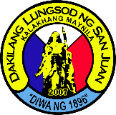

Republic of the Philippines
City Government of San Juan
METRO MANILA
- 000-
City Disaster Risk Reduction and Management Department

SARIPADA L. PACASUM JR.
Dept. Head, CDRRMD
City Government of San Juan

